LGCWEEK xXx - ???????
Colour key - Venn Jordan Pedro
The Jordan
https://meet.jit.si/jordan9000#config.disableAP=true&config.disableAEC=true&config.disableAGC=true

The Pedro
https://meet.jit.si/pedro9000#config.disableAP=true&config.disableAEC=true&config.disableAGC=true

Need to remember - post finished show in google Linux group.

PICK YOUR FUKIN’ STORIES!

Remember to ask shatrealm to come up with Show Title.

Intro-
grep ^http links.txt | tr "\n" " " | sed 's/\&/\\\&/g' | xargs firefox lynx curl

Vote for Showtitles: vote.linuxgamecast.com

INTRO : ???????????????????????????? <- !!!!!!!!!!!!!!!!

Anyone want to stay up for this?
http://ir.amd.com/news-releases/news-release-details/amd-livestream-dr-lisa-su-computex-2019-keynote

10:00 a.m. Taipei Standard Time == 10 PM EDT

Rundown:

Coming up this week, how do you kill something that is already dead?
And yes, I am talking about the last remaining whitewalker, Interstellar Marines
And GOG wishes Linux users Peace among worlds, in stereo.
But, maybe, just maybe, there is a silver lining.

Valve doesn’t want you to get too positive
- Even if you do wanna have a notre damn good time
After 10000 years you can finally play PCSX2 games online
- Now you have two ways to play Final Fantasy 11

VALVe talks about the Top 20 of April
- Gotta stroke those egos a bit more if you want to keep them away from Epic
And NVidia had a Super announcement
- Amazing how you can call something Super without actually showing anything

What we’re up to :
V - We’re now an official Amazon YT influencer, fam. Came with a new affiliate ID & store. Also, Threadbooper adds about 5/7 $ to the powah bill for anyone wondering.
J -
P -

Colour key: Venn Jordan Pedro
Party Patreons: Post story suggestions HAR!

1. Bee hive sim, written in Godot 3 https://cheeseness.itch.io/honeycomb-crunch/devlog/82704/honeycomb-crunch-released
2.
3.
4.

Links
Steam: News

Positive review bombs
https://steamcommunity.com/games/593110/announcements/detail/1621770561051427036
- Some interesting ponderings regarding content vs context and how it can affect purchasing patterns
- The short version is that for now, stuff like wat Ubi was doing in the wake of the Notre Dam fire won’t be counted as review bombs.
  - Although I did find it interesting that it didn’t really affect the score by a significant degree even if they did count the positive reviews as a review bomb
- I’m sure positive review bombs in general will get this treatment.
- How long until someone games this?
- Like positively bombing a certain game which is seen as anyway competing with a second game for which the developers/publishers did something naughty?
- Will VALVe actually take the time to do something about it?
- Again, solve all this in one go by allowing reviews of developers / publishers.

Sup stud
https://steamcommunity.com/games/593110/announcements/detail/1621770561065348220
- 3 Apps seems a little much.
- I genuinely think they would get better adoption if the link, chat and authenticator app all stayed in one download.
- 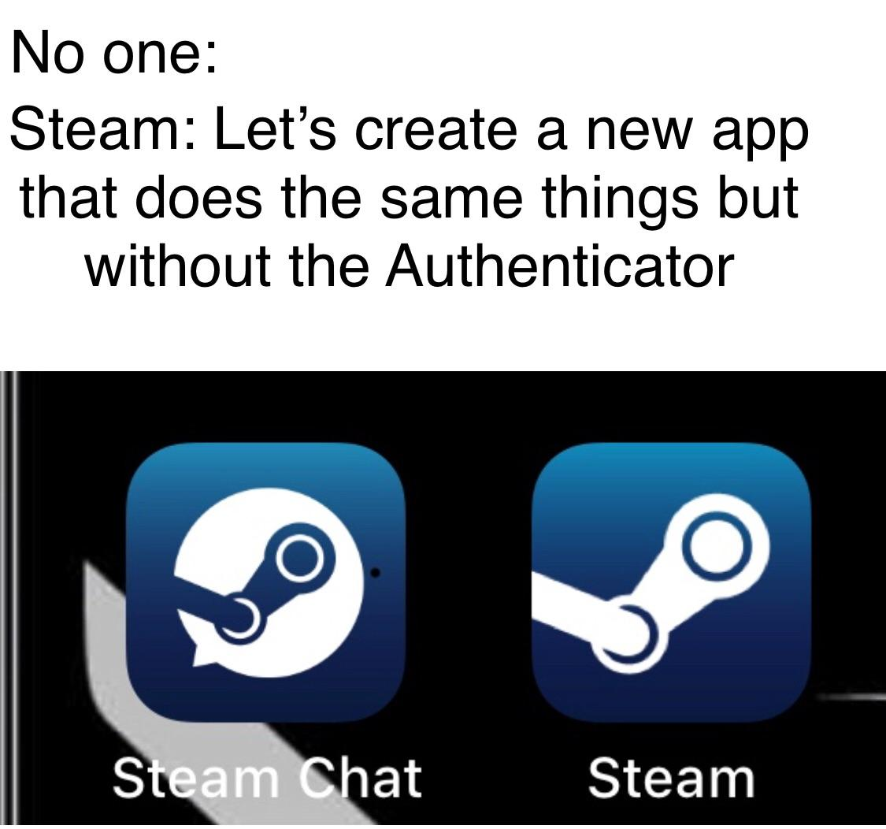
- Even Facebook ditched the dedicated messenger app.
- Hey, VALVe! You should be looking at what Epic is doing to poach games away from you not competing with Discord/WhatsApp.
  - You mean throwing money at publishers and not improving their platform?
- Does anyone actually use Steam for chat?
- I’m not hating but I might have had 7 or so conversations in 5+ years.

Steam beta brings the rumble
https://steamcommunity.com/groups/SteamClientBeta#announcements/detail/1612764629382440848
- That only took what, three years?
- 100% going to surprise someone leading to a Steamy controlla launch.
- Also fixes DS4/DS3 rumble if you enable Steam Input on them.
- Also maybe steve overlay doesn’t look like crap on vulkan titles now?

Top 20
https://steamcommunity.com/games/593110/announcements/detail/2565275416677184326
- Some human beings are subject to flattery and protagonism, the same kind of humans which might be looking to Epic to find these things in a less crowded market.
- That’s a start, VALVe! Minimum effort and something you will easily be able to automate going forward, but it’s a start.
- Kinda disappointing to see only two linux games in the mix.
  - Gotta rep that 1.3%.

Proton
https://github.com/ValveSoftware/Proton/wiki/Changelog#42-5
- Granting DXVK wishes.
- I get the sense that a lot of these future proton updates are just going to be pulling the latest DXVK
- Integration of Steam Sockets is interesting.
- I wonder what the actual effect will be?
- The Surge now runs at 2560x1440 at around 60 FerPS.
- @1080p it went from around 60 to around 80, in most places.
Steam: Game Updates

Interstellar Marines
https://steamcommunity.com/app/236370/discussions/0/3557193237107908317/
- Reining Early Access champion.
- I keep forgetting this game exists.
- If you have to start an announcement with “rumours of our death” it’s dead.
- According to steamcharts, the average players in game these days is 2.8.
- It’s dead jim.

Streets of Rogue beta 77
https://steamcommunity.com/games/512900/announcements/detail/1626275428271639763
- Good time to ask the community to help test new stuff, since it’s in the tinyBuild bundle.

Dead Cells Update 13
https://steamcommunity.com/games/588650/announcements/detail/1610512829571706448
- Dead cells gets some balance updates based on player feedback
- Basically boils down to some of the enemies were too good in the context where they’re encountered, so they got nerfed as a result
- Also trying to make aggressive builds more viable
Steam: New Games

Valve Auto Chess
https://www.pcgamer.com/valve-is-making-a-standalone-version-of-dota-auto-chess/
- You made this, I made this.
- China gets the standalone non-dota version, the rest of us get the dota-fied one
- S’not the first time Valve has done something like this.
- What with Dota proper and Narbacular Drop
- We did mention that VALVe had bought this, so might as well release it officially and monetise the shit out of it.

Total War: THREE KINGDOMS
https://store.steampowered.com/app/779340/Total_War_THREE_KINGDOMS/
- New skin pack for the eighteen year old graphics engine.
- I guess if you enjoy this genre and are on Linux, you probably need to create a shrine to Feral in your den.
- Dat price tho!
- $71 CAD is way more than I’d think anyone would reasonably pay for an outdated grand strategy game.
  - We both know the people hella into this didn’t even blink at the price.
  - Both of them.
Plugs
Patreon:
- Discord
- Early note access
- Name in credits
- Access to UNCUT VOD’s 3 days early.
- RSVP for game streams.
- Buy your way onto the damn show.

PATREON
Shirts
Amazon store (don’t mention refs)

A list of shite we use in the studio
https://www.amazon.com/shop/linuxgamecast
- Tickle your inner voyeur.
- A borderline comprehensive list, store... thingy of everything in our studio.
- 100% Linux compatible, as FSM intended.

News:

Nvidia super
https://www.pcgamesn.com/nvidia/geforce-something-super
- Slightly faster and cheaper Navi competitors.
- About time they released Quake II RTX.
- Give me a $100 TU NVENC device.
- Anyway, I look forward to the new table / mobile.
- I’m sure it’ll be super uninteresting.
- That’s usually what happens when you’ve gone this long without competition.
- Though, a 1650Ti with Turing NVEnc would certainly be welcome.
- Everyone wants the 1650 Super thanks for asking. I don’t think we’re going to get it. Nvidia’s MO is “charge more for the features you actually want”

DXVK 1.2.1
https://github.com/doitsujin/dxvk/releases/tag/v1.2.1
- I look forward to the Proton version which includes this version of dxvk, only just so I can finish The Surge.
- That game takes a serious hit to the FerPS about half-way through.
- It’s also almost unplayable in UHD as it is.
- Well, hot damn! We usually get a week or so before Proton updates to include the new stuff.

PCSX2 Finally gets netplay
https://www.reddit.com/r/linux_gaming/comments/bq4dbw/pcsx2_finally_gets_netplay_support_on_linux_and/
- Someone finally got around to it
- Doesn’t let you do couch multiplayer over a network, but you can at least hit the fan servers from some of the PS2 Online games

New GOG no Linux
https://twitter.com/GOGcom/status/1131235847926362112
https://www.gogalaxy.com/en/
- Ya know what, I’m done buying shite on GOG.
- That said I’m curious how their “open source” idea pans out.
- Considering that until a few weeks ago you needed to email a guy for FTP credentials to push your linux binary, I’m not surprised at all
- Even sadder still, the new galaxy is done in QT.
- It’s basically just spite now
  - I don’t think it’s spite.
  - Genuinely think it’s ignore until go away.
- Yup, GOG can rot until the Linux version of Galaxy is out.
- It’s the most requested feature but FK us, amiright?
- At the end of the day I’m not mad, nay, mearley disappointed.

CHAIRQUISITION:
- Nooope
- Not sure if want
- Check it out
- Shutupandtakemymonies

Welcome to the Chairqasition!
Where the accused must survive trial by Fedora, Solus, and Ubuntu Fedorf.
Then and only then can the question be asked, is it fun?

Game: Clustertruck (humbletinyb bundle)
Webzone: https://store.steampowered.com/app/397950/Clustertruck/
Devel: Landfall
Engine: Unity
Price: £10.99 / US$14.99 / CA$16.99
Wazzat: Clustertruck is a chaotic physics based truckformer. Jump your way through insane levels in a game of "the floor is lava" on top of speeding trucks driven by terrible drivers.

Mandatory Disclosure:

Pass|Fail 


Venn:
Does It Launch
- Scream of nope.
Performance @ 1080
- Hold 60 /w everything on 11 @ 2160.
Graphics
- Remember lawnmower mang?
Control
- Xclone worked OOTB.


Jordan:
Does It Launch
- Hello unity scream of nope my old friend
Performance @ 1080
- Runs OK on both the 580 and the 1080TI Holds 60
Graphics
- There are trucks, and trees and obstacles. You can see them all
Control
- I mean, the Dualshock worked, You may want to resort to wasd


Pedro:
Does It Launch
- Unity screen of nope and pointless folders on my $HOME
- It even throws in an extra fuck you, being that the folders have fucking nothing in them
Performance @ 1080
- It holds 60 but, if you enable TSAA and the Ambient Occlusion, the FerPS do drop slightly during level transitions at UHD
Graphics
- Something is wrong with that blur filter that TSAA introduces.
- Not enough to ding it a chair, but there are places on screen where it’s just not applied.
Control
- I almost want to ding it another chair for that mess of a controls tab on the Screen of Nope

QA Score:
Fedora:
Soulless:
Ubuntu:

Fun section:
Fun?:
- Venn:
  - It passed the “oh hell, I better get my legs out from under the desk” test.
  - Ya doing something right right there.
  - It’s a run, jump, die RNG borlinening on BS simulator done right.
  - Then the mutators show up!
  - No need for instructions and it even managed to elicit an emotional response.
  - Granted, that emotion was anger but it was the happy fun kind.
  - I was able to get right up to area two before using the controlla was merely extra hard mode that I lacked the skill to overcome.
  - Grabbed the gerbil and ended up in this odd stretched position because I had to keep my knees far away from the desk.
  - I managed to BS another level that way but had to tap out due to the contortion required.
  - Didn’t want to wake up tomorrow with no feeling in my left pinky toe, again.
  - It’s silly fun and since you can get it in this weeks Bundle for $7 we stinky, do it.
  - It’s probably going to be the best game during this month's find games that leave folders in Pedro’s home directory challenge.
- Jordan
  - It’s another one of these rage platformers that insists on being in first person and not showing you your feet
  - I’m sure there is some strategy that you can use to squeeze out second and stunts, but I haven’t stumbled on it yet
  - It’s a little enjoyable to run around, jump and slam into things and occasionally make it to the finish line, but after a while it just gets a little too fucky for my taste
  - And unlike something like perineum, I can’t really tell what the hell I’m doing wrong. Everything is wonderfully inconsistent
- Pedro
  - Is it fun? Yes, it is!
  - This is one of those games that keeps me leaning all the way forward at the edge of my chair.
  - It’s very satisfying to be able to beat a level in the first couple of tries.
  - Unfortunately, like these past weeks, that stupid pointless folder it creates in my home directory is a nasty habbit that needs to fucking die.
  - Three weeks in a row and all three required differently named folders for me.
  - So, once again, another game loses a chair for its technical incompetence.
  - It is fun, though!

Fun Score:
Venn:
Jordan:
Pedro:

Hate Mail:

IRKALLA
https://linuxgamecast.com/bradley/?HVAWs2o
http://www.irkallagame.com/press/index.php#trailers

Lecording
https://linuxgamecast.com/bradley/?mFKoEYF

After:

Jack Attack, bitches!

